TASK 3 - Minikube Deployment Task

**NAME**: SURYA U S

**ROLLNO**:22CSR214

# STEP 1: START MINIKUBE

**Start the Minikube cluster using the following command:**

minikube start

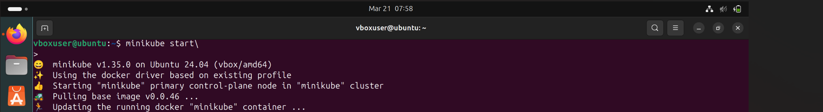

**This initializes the Minikube cluster using Docker as the driver.**

# STEP 2: INSTALL KUBECTL

**Since Kubectl is not found, install it with the following command:**

sudo snap install kubectl –classic

Alternatively, you can download it using curl:



curl -LO "https://dl.k8s.io/release/$(curl -L -s https://dl.k8s.io/release/stable.txt)/bin/linux/amd64/kubectl" sudo install -o root -g root -m 0755 kubectl /usr/local/bin/kubectl

# STEP 3: VERIFY KUBECTL INSTALLATION

kubectl version –client

# STEP 4: CREATE A DEPLOYMENT

**Create a deployment named `z` with the image `surya22csr214/dev:** kubectl create deployment z --image=surya22csr214/dev --port=80



# STEP 5: EXPOSE THE DEPLOYMENT

**Expose the deployment as a NodePort service:**

kubectl expose deployment z --port=80 --type=NodePort



# STEP 6: VERIFY THE POD

**Check the running pods:**

kubectl get pods



# STEP 7: ACCESS THE SERVICE

**Expose the service using Minikube and get the URL:**

minikube service pod1

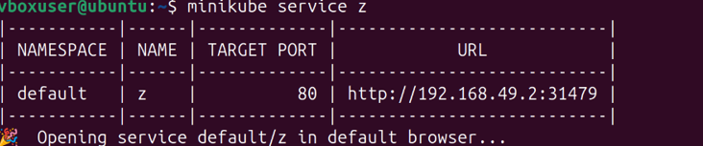

**STEP 8: OUTPUT IN THE WEB BROWSER**

